
INFOPharma Ordering System (IPOS)
Server Application Subsystem


by the Engine ROOM

Contents

1.1 Purpose and scope of the document (what it is and what is NOT)
1.2 Intended audience and Reading Suggestions
1.3 History of the document
2 Introduction
3 Glossary
4 User requirements
System Requirements
Purpose and Scope of the system
System Models
UML use case model

7 IPOS High-Level Design
This section contains the
Component Diagram
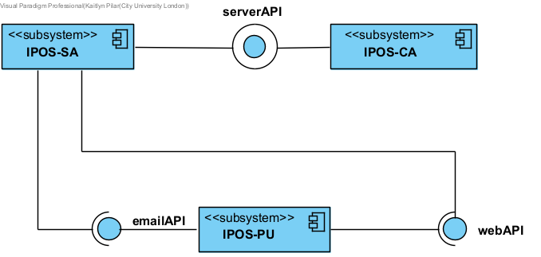
Figure 2

